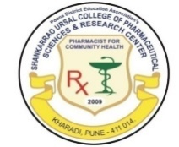
Pune Districts Education Associations
Shankarrao Ursal College of Pharmaceutical Sciences &
Research Centre, Kharadi, Pune-14.
__________________________________________________________
A Report on
PDEA District Level Sports Competition 2025-26
During the Academic Year 2025–26, Pune District Education Association’s Shankarrao Ursal College of Pharmaceutical Sciences and Research Centre, Kharadi, actively promoted sports and physical education as an integral component of holistic student development. Students participated enthusiastically in group level, district level, inter-collegiate, and institutional sports events organized under PDEA and Savitribai Phule Pune University.
At the PDEA Group Level Sports, in Hadapsar group the institution Boys and Girls team participated in Volleyball, Kabaddi, Athletics, and Kho-Kho competitions in November 2025. Events were hosted at PDEA institutions including Annasaheb Magar College Hadapsar, College of Pharmacy Hadapsar, Waghire College Saswad, and Shankarrao Ursal College of Pharmaceutical Sciences and Research Centre, Kharadi. Our College D. Pharm, B> Pharm, and M. Pharm 45 students represented the college, demonstrating teamwork, discipline, and sportsmanship.
The college also took part in PDEA District Level Sports Competitions conducted in 29th and 30th December 2025 at PDEA’s Waghire College Saswad. Indoor events included Chess, Wrestling, Karate, Taekwondo, and Yoga, while outdoor events comprised Volleyball, Kabaddi, Athletics, and Kho-Kho. The institution achieved commendable results at the district level, with teams securing runner-up positions in Volleyball, Kabaddi, and Kho-Kho for both boys and girls.
In individual events, students achieved notable success. Medals were secured in Chess, Karate, Taekwondo, and Athletics, including gold, silver, and bronze medals, reflecting the students’ competitive spirit and consistent training. Among the indoor competition chess competition hosted by our institute. Total 238 participants noted their performance in chess competition. Details of result and participation enclosed with report.
PDEA officials and our College Principal Dr. Ashok Bhosale congratulate all winners, appreciate all participants for their active participation as well as sport coordinators for successful coordination. Sports activities contributed significantly to the development of physical fitness, leadership qualities, teamwork, and overall personality development of students, aligning with quality indicators for student support and progression.

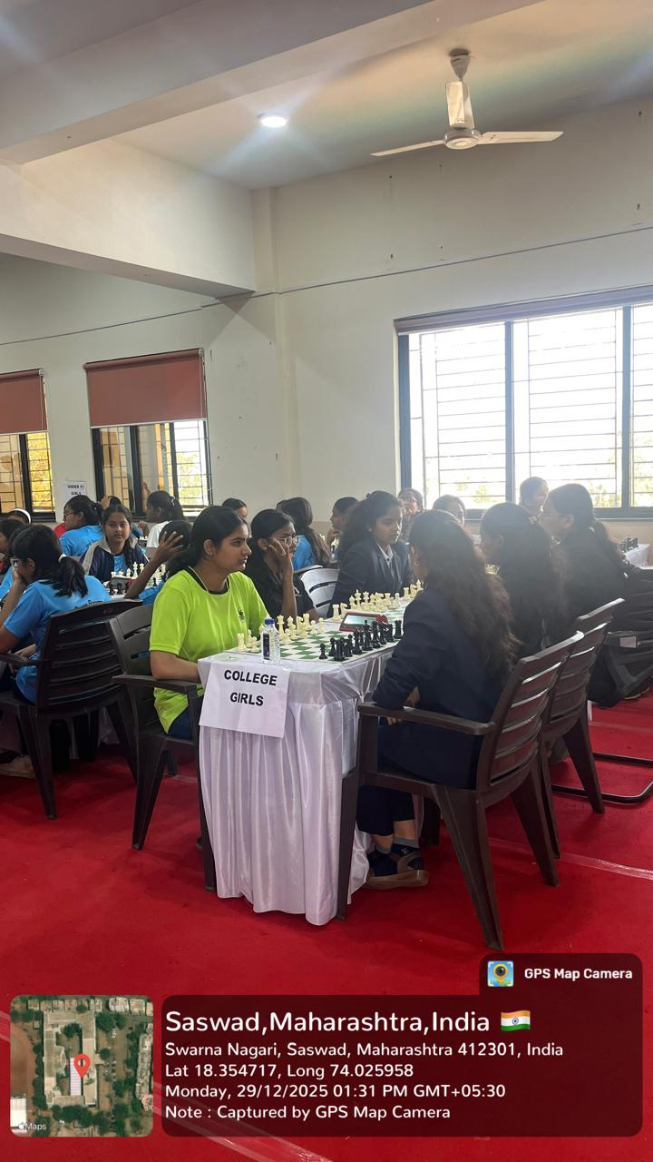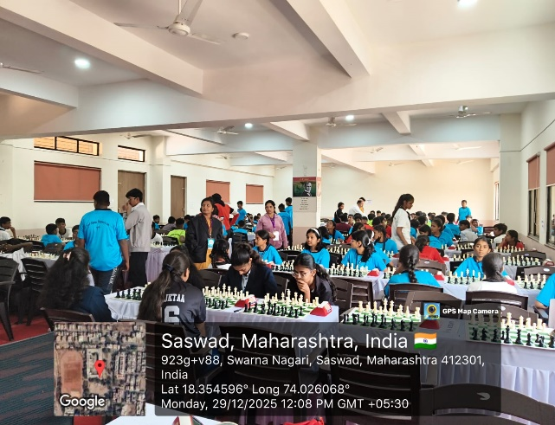

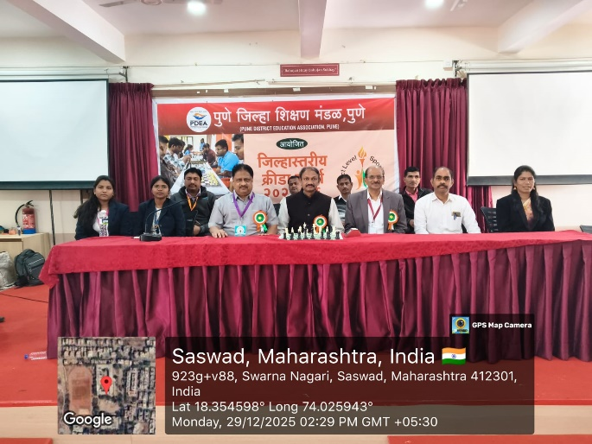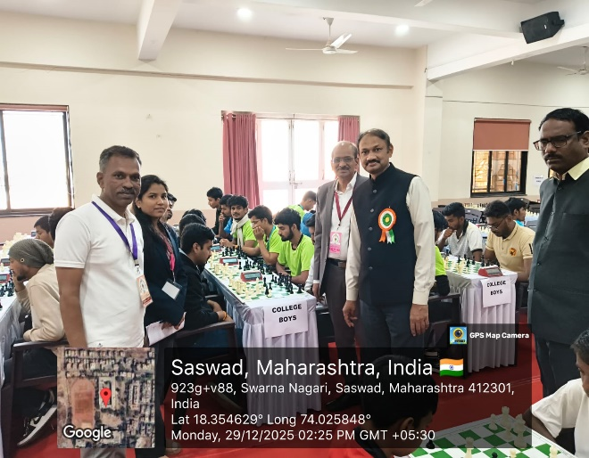

Memorable moments from the PDEA District-Level Chess Event. More pics with PDEA officials and prize distribution

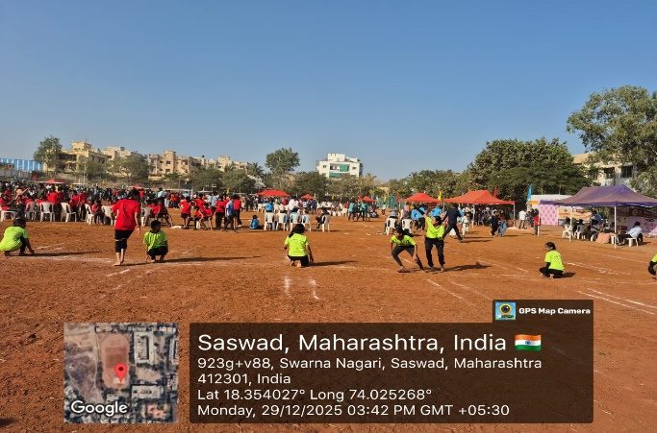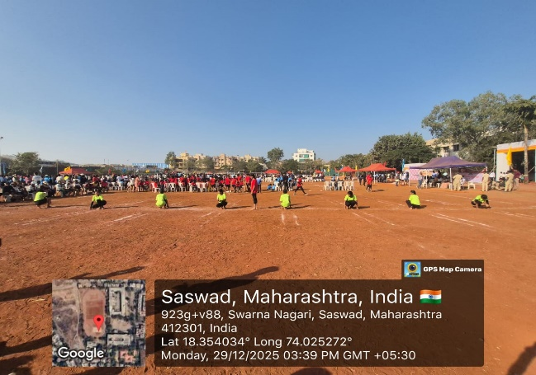

Memorable moments from the PDEA District-Level Kho-Kho Event.”

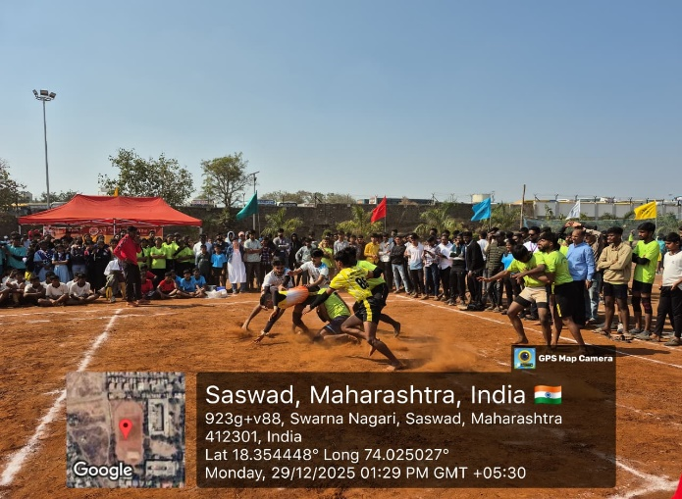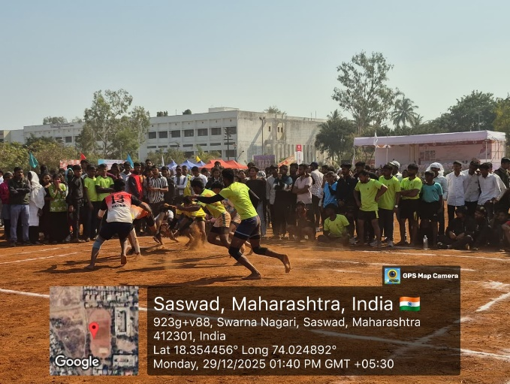

Memorable moments from the PDEA District-Level Kabbadi Event.”

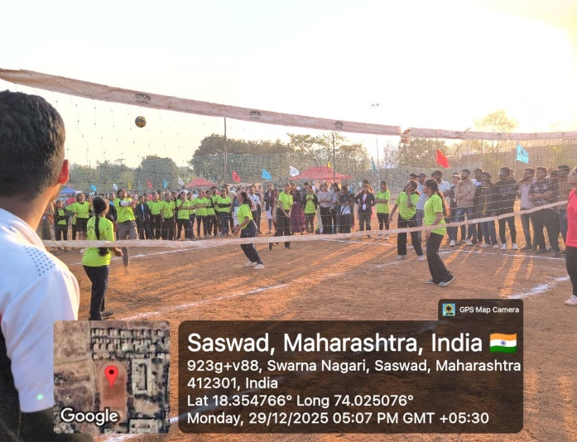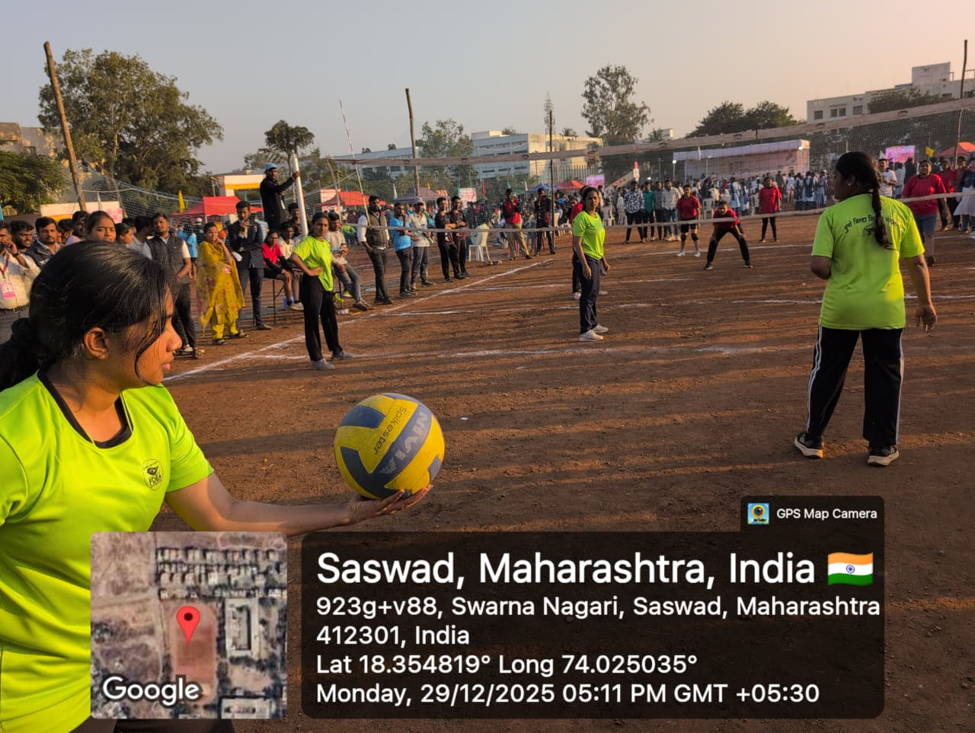

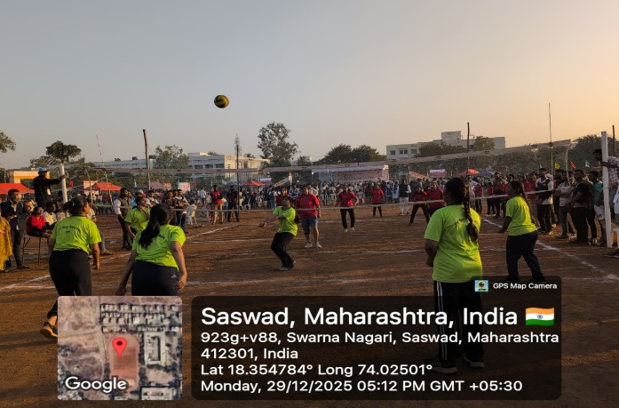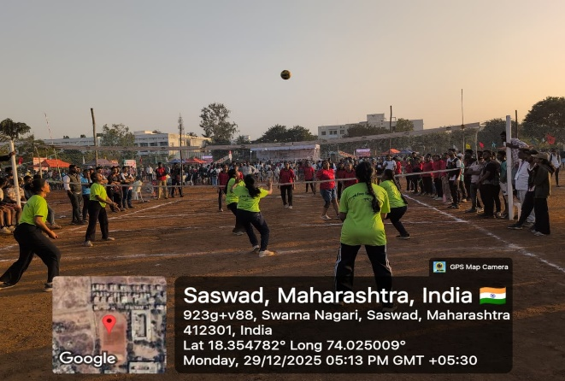

Memorable moments from the PDEA District-Level Volleyball Event’

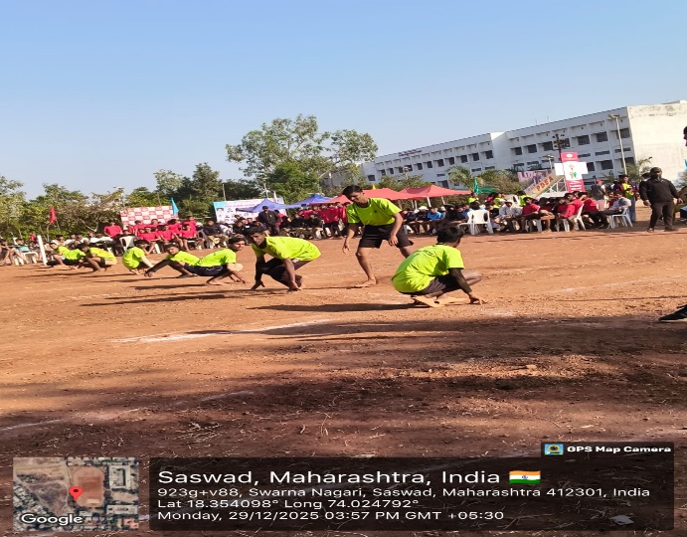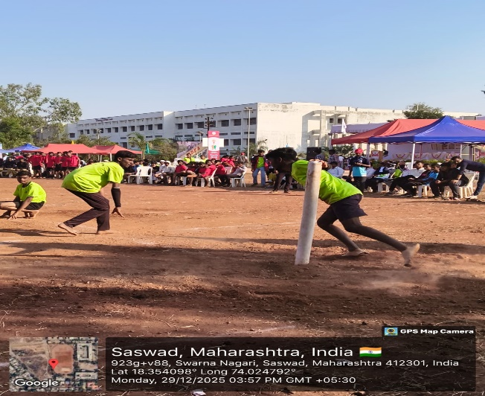
Memorable moments from the PDEA District-Level Volleyball Event. Its kho-kho

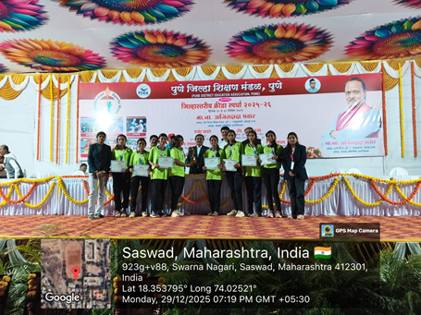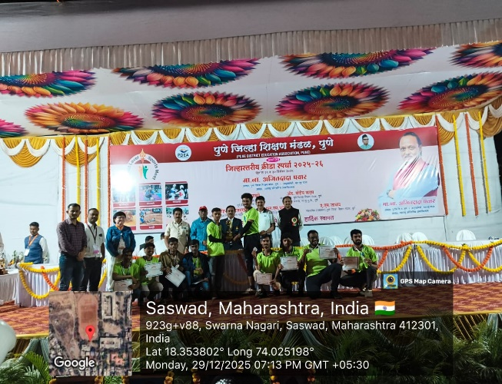

A Proud Moment of Excellence and Accomplishment. Other pics of prize distribution with all PDEAofficials

